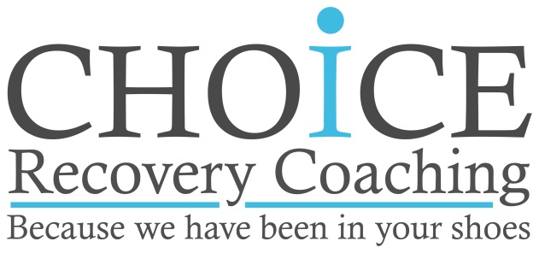
Scholarship Program Application

Name: ____________________________________________ Gender: ____________ Date: _____________ Address: __________________________________________________________________________________ _________________________________________________________________________________________Telephone: _________________________________ Email: ________________________________________

Tell us a little bit about yourself:_______________________________________________________________
______________________________________________________________________________________________________________________________________________________________________________________________________________________________________________________________________________
_________________________________________________________________________________________
_________________________________________________________________________________________

Describe your motivation for wanting to become a Recovery Coach: __________________________________ ______________________________________________________________________________________________________________________________________________________________________________________________________________________________________________________________________________
__________________________________________________________________________________________

What experience and skills do you possess that you imagine would complement you as a Recovery Coach? ___
______________________________________________________________________________________________________________________________________________________________________________________________________________________________________________________________________________

Which Pathways of Recovery do you currently support? ____________________________________________
__________________________________________________________________________________________
__________________________________________________________________________________________

What would be challenging about committing to this 6-month program? _______________________________
__________________________________________________________________________________________
__________________________________________________________________________________________
__________________________________________________________________________________________
__________________________________________________________________________________________

Please return your completed application to: recovery@choicerecoverycoaching.org

www.choicerecoverycoaching.org ~ 155 Maple Street Ste. 301 Springfiield MA 01105 ~ 413-272-8520

